Supplementary Materials for
Thermodynamic conditions control the valences state of semimetals thus affecting the behavior of PGE in magmatic sulfide liquids
Qing-Lin Liang¹, Xie-Yan Song^{1 *}, Richard Wirth², Lie-Meng Chen¹, Song-Yue Yu¹, Nadezhda A. Krivolutskaya³, Zhi-Hui Dai¹

¹ State Key Laboratory of Ore Deposit Geochemistry, Institute of Geochemistry, Chinese Academy of Sciences, Guiyang, PR China
² German Research Centre for Geosciences GFZ, 3.5 Surface Geochemistry, Telegrafenberg, Potsdam, Germany
³ V. I. Vernadsky Institute of Geochemistry and Analytical Chemistry, Russian Academy of Sciences, 19 ul. Kosygina, Moscow, 119991, Russia.
*Corresponding author: Xie-Yan Song (songxieyan@vip.gyig.ac.cn)

This file contains:
- Texts S1-S2.
- Figs. S1-S6.
- Captions for Tables S1, S2 (as the Excel file which is uploaded separately), S3, S4, S5 (include Table S5a and 5b).
- Cited references.

Text S1. Samples
Fractionation crystallization modelling of the sulfide liquids was carried out for orebody No. 24 of the Jinchuan deposit and Talnakh ore junction of the Noril’sk district (simplified as Jinchuan deposit and Noril’sk deposits, respectively) (Fig. 1) using the whole-rock data of Ni and PGE (Table S1). We used 97 samples from the Noril’sk deposits (84 samples described by Duran et al., 2017 and Zientek et al., 1994 and 13 samples we analyzed) and 83 samples from the Jinchuan deposit (64 samples described by Chen et al., 2013 and 19 samples we analyzed) for the modelling (Table S1). The 13 samples from the Noril’sk deposits were collected by Xie-Yan Song, Lie-Meng Chen and Song-Yue Yu from underground drifts of the Skallsty mine, Taymyrsky mine and Oktyabr’sky mine (Table S1; Fig. 1B) during the prior-meeting field trip of the 12th International Platinum Symposium. The 19 samples from the Jinchuan deposit were collected by Xie-Yan Song and Lie-Meng Chen from underground drift. The early cumulated sulfide phase of the two deposits plot on MSS cumulate trends (Fig. S1). Accordingly, 4 massive ores (described by Chen et al., 2013) from the Jinchuan deposit (Table S1; Fig. 1A) and 5 massive ores (analyzed this time) from the Noril’sk deposits (Table S1; Fig. 1B) were selected for further in-situ studies.
One representative thin section or block of each the Jinchuan and Noril’sk massive ores was prepared and observed using a conventional optical microscopy at the Institute of Geochemistry, Chinese Academy of Sciences (IGCAS). Two representative areas (~0.5 cm × 0.5 cm, ~1.5 cm × 1.5 cm) on each thin section or mount were mapped (back-scattered electron-mapping) using a FEI Scios SEM at magnifications of 1000 and 500, respectively at the IGCAS. Platinum-group minerals (PGM) have a brighter contrast on a back-scattered electron image compared to base metal sulfides (BMS), which were located offline then analyzed using the FEI Scios SEM.
In the Jinchuan massive ores, the proportions of pyrrhotite, pentlandite and chalcopyrite are approximately 75:20:5. The average composition of the pyrrhotite is Fe_{0.87}S (Table S4). Pentlandite mainly occurs as large subhedral grains, chain-like polycrystalline aggregates around pyrrhotite grains and occasionally as exsolution flames in pyrrhotite grains. Chalcopyrite was found as small anhedral grains randomly dispersed between pyrrhotite and/or pentlandite grains (Figs. 2A-B).
The Noril’sk massive ores are quite fresh and characterized by high abundance of pyrrhotite (>70-75 vol%) with less than ~10 vol% of chalcopyrite and variable abundances of pentlandite. The average composition of the pyrrhotite is Fe_{0.89}S (Table S4). Pentlandite mainly appears as large subhedral grains, chain-like polycrystalline aggregates around chalcopyrite (loop textured pentlandite, formed through a peritectic reaction between MSS and evolved sulfide liquids (Mansur et al., 2019a)) and pyrrhotite (Figs. 2C-D) and occasionally as exsolution flames within pyrrhotite grains (Fig. 2C). Chalcopyrite occurs as small anhedral grains (Fig. 2C) or millimeter (Fig. 2D) to centimeter sized patches. Euhedral to subhedral magmatic magnetites were commonly found in the massive ores with proportions of 5-12 vol% and diameters of 0.2-0.5 mm (Fig. 2D).
As shown in the plots of whole-rock semimetals concentrations (in 100% sulfide) versus (Pt+Pd)/(Ir+Ru+Rh) values, Te, Bi and As correlate positively with (Pt+Pd)/(Ir+Ru+Rh) (Fig. S2) for Jinchuan (Figs. S2B-C) and Noril’sk (Figs. S2D-F) sulfide ores, except the Jinchuan Cu-rich ores which have relatively constant As concentrations as (Pt+Pd)/(Ir+Ru+Rh) increase (Fig. S2A).
Text S2. Analytical methods
Whole-rock S, metal and semimetal analyses
A LECO CS844 was used to measure whole-rock S contents using IR-absorption with the detection limits ~0.01 wt% at the Mineral-ALS Chemex (Guangzhou) Co., Ltd. Whole-rock Ni and Cu contents were measured by Inductively Coupled Plasma-Optical Emission Spectrometry (ICP-OES) and semimetals contents were determined by Inductively Coupled Plasma Atomic Fluorescence Spectroscopy (ICP-AFS) at the Mineral-ALS Chemex (Guangzhou) Co., Ltd.
Platinum-group elements abundances were measured by Isotope Dilution Inductively Coupled Plasma Mass Spectrometry (ID-ICPMS) using an improved digestion technique (Qi et al., 2011) at the IGCAS. Sample powders were digested by HF and HNO₃ in poly tetra fluoroethylene (PTFE) beaker to remove silicate and sulfide. The dried residual was digested with HF+HNO₃ at 190 °C for 48 h. The PGE within the final solution were then collected using a Te-coprecipitation approach (Qi et al., 2004). Precision and accuracy are better than 10% as demonstrated by analyzing reference materials UMT-1 and WPR-1 (Qi et al., 2004, 2008).
EPMA analyses for BMS
Major elements of the BMS from the Jinchuan and Noril’sk massive ores were measured using a JXA8530F-plus Electron Probe Microanalysis (EPMA) at the IGCAS. The standards (supplied by Structure Probe, Inc.) were pentlandite for S, Co, Ni and Fe and chalcopyrite for Cu. The analyses were carried out using an electron beam diameter of 10 μm, a beam current of 10 nA and an accelerating voltage of 25 kV. The counting time for each element on peak and background were 20s and 10s, respectively.

Figs. S1-S4
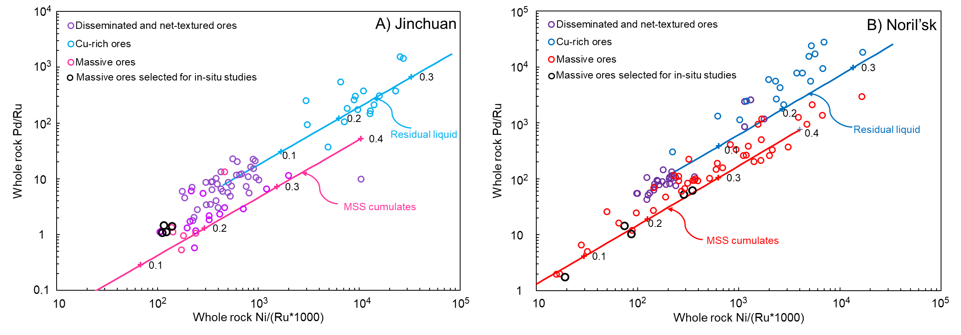
Fig. S1. Fractionation crystallization modelling for the sulfide liquids from orebody No. 24 of the Jinchuan deposit (simplified as the Jinchuan deposit below) (A) and Talnakh ore junction of the Noril’sk district (simplified as the Noril’sk deposits below) (B). Whole-rock data are listed in Table S1. Data sources for the Jinchuan deposit: this study and Chen et al. (2013), data source for the Noril’sk deposits: this study, Duran et al. (2017) and Zientek et al. (1994). MSS cumulates and residual liquid trends were calculated using a Rayleigh equation. Crosses annotated with numbers represent the degrees of fractionation. The sulfide liquid of the Jinchuan deposit was assumed to contain 9.9 wt% Ni, 250 ppb Ru and 1700 ppb Pd according to Chen et al. (2013). The sulfide liquid of the Noril’sk deposits was assumed to contain 4.97 wt% Ni, 286 ppb Ru and 28243 ppb Pd according to the average composition of disseminated ores (Zientek et al., 1994). D_{Pd}^{MSS/Sul} = 0.133 and D_{Ru}^{MSS/Sul} = 13 (Li at al., 1996; Liu et al., 2015; Mungall et al., 2014) were used in the modelling. It is assumed that D_{Ni}^{MSS/Sul} is 0.6 at the beginning of fractionation and increases gradually to 0.9 when ~50% of the system has solidified (Mungall et al., 2005).

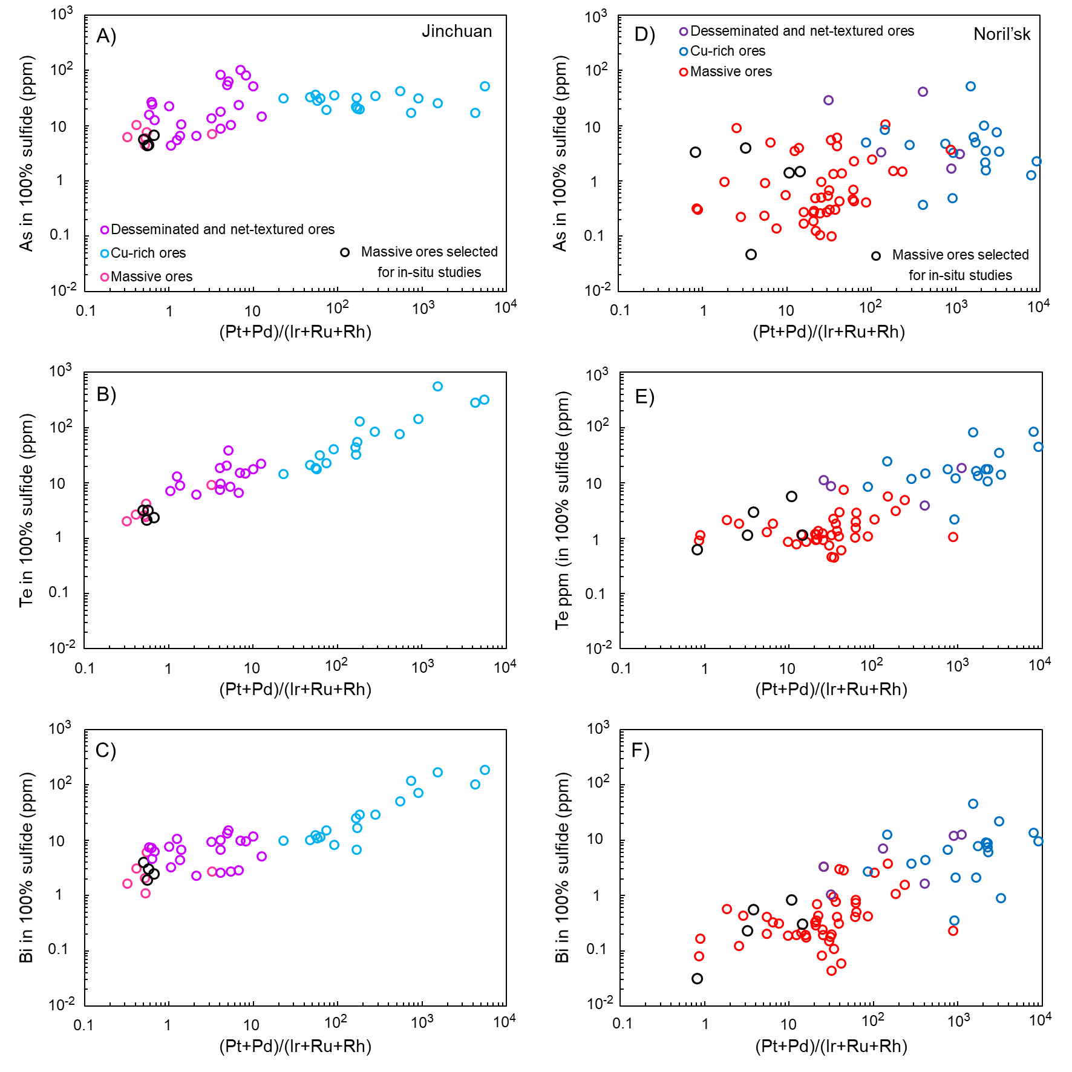
Fig. S2. Binary plots of whole-rock semimetals (in 100% sulfide) versus (Pt+Pd)/(Ir+Ru+Rh) for the sulfide ores from the Jinchuan deposit (A-C) and the Noril’sk deposits (D-F). The whole-rock data are listed in Table S1. Data sources for the Jinchuan deposit: this study and Chen et al. (2013), data source for the Noril’sk deposits: this study, Duran et al. (2017) and Zientek et al. (1994).
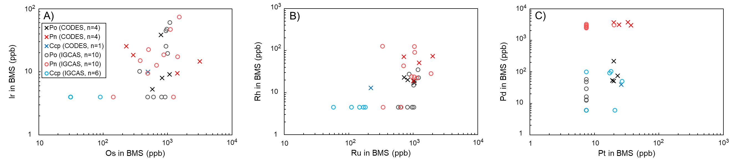
Fig. S3. A comparison of the LA-ICP-MS results for JC06-806 (one of the massive ores from the Jinchuan deposit) acquired at CODES, University of Tasmania (Chen et al., 2015) and at the Institute of Geochemistry, Chinese Academy of Sciences (IGCAS) (Table S2). The data acquired at the two labs show good consistencies for Ir, Rh, Pt and Pd. Os and Ru concentrations in chalcopyrite acquired at the IGCAS are slightly lower compared to the data acquired at CODES.

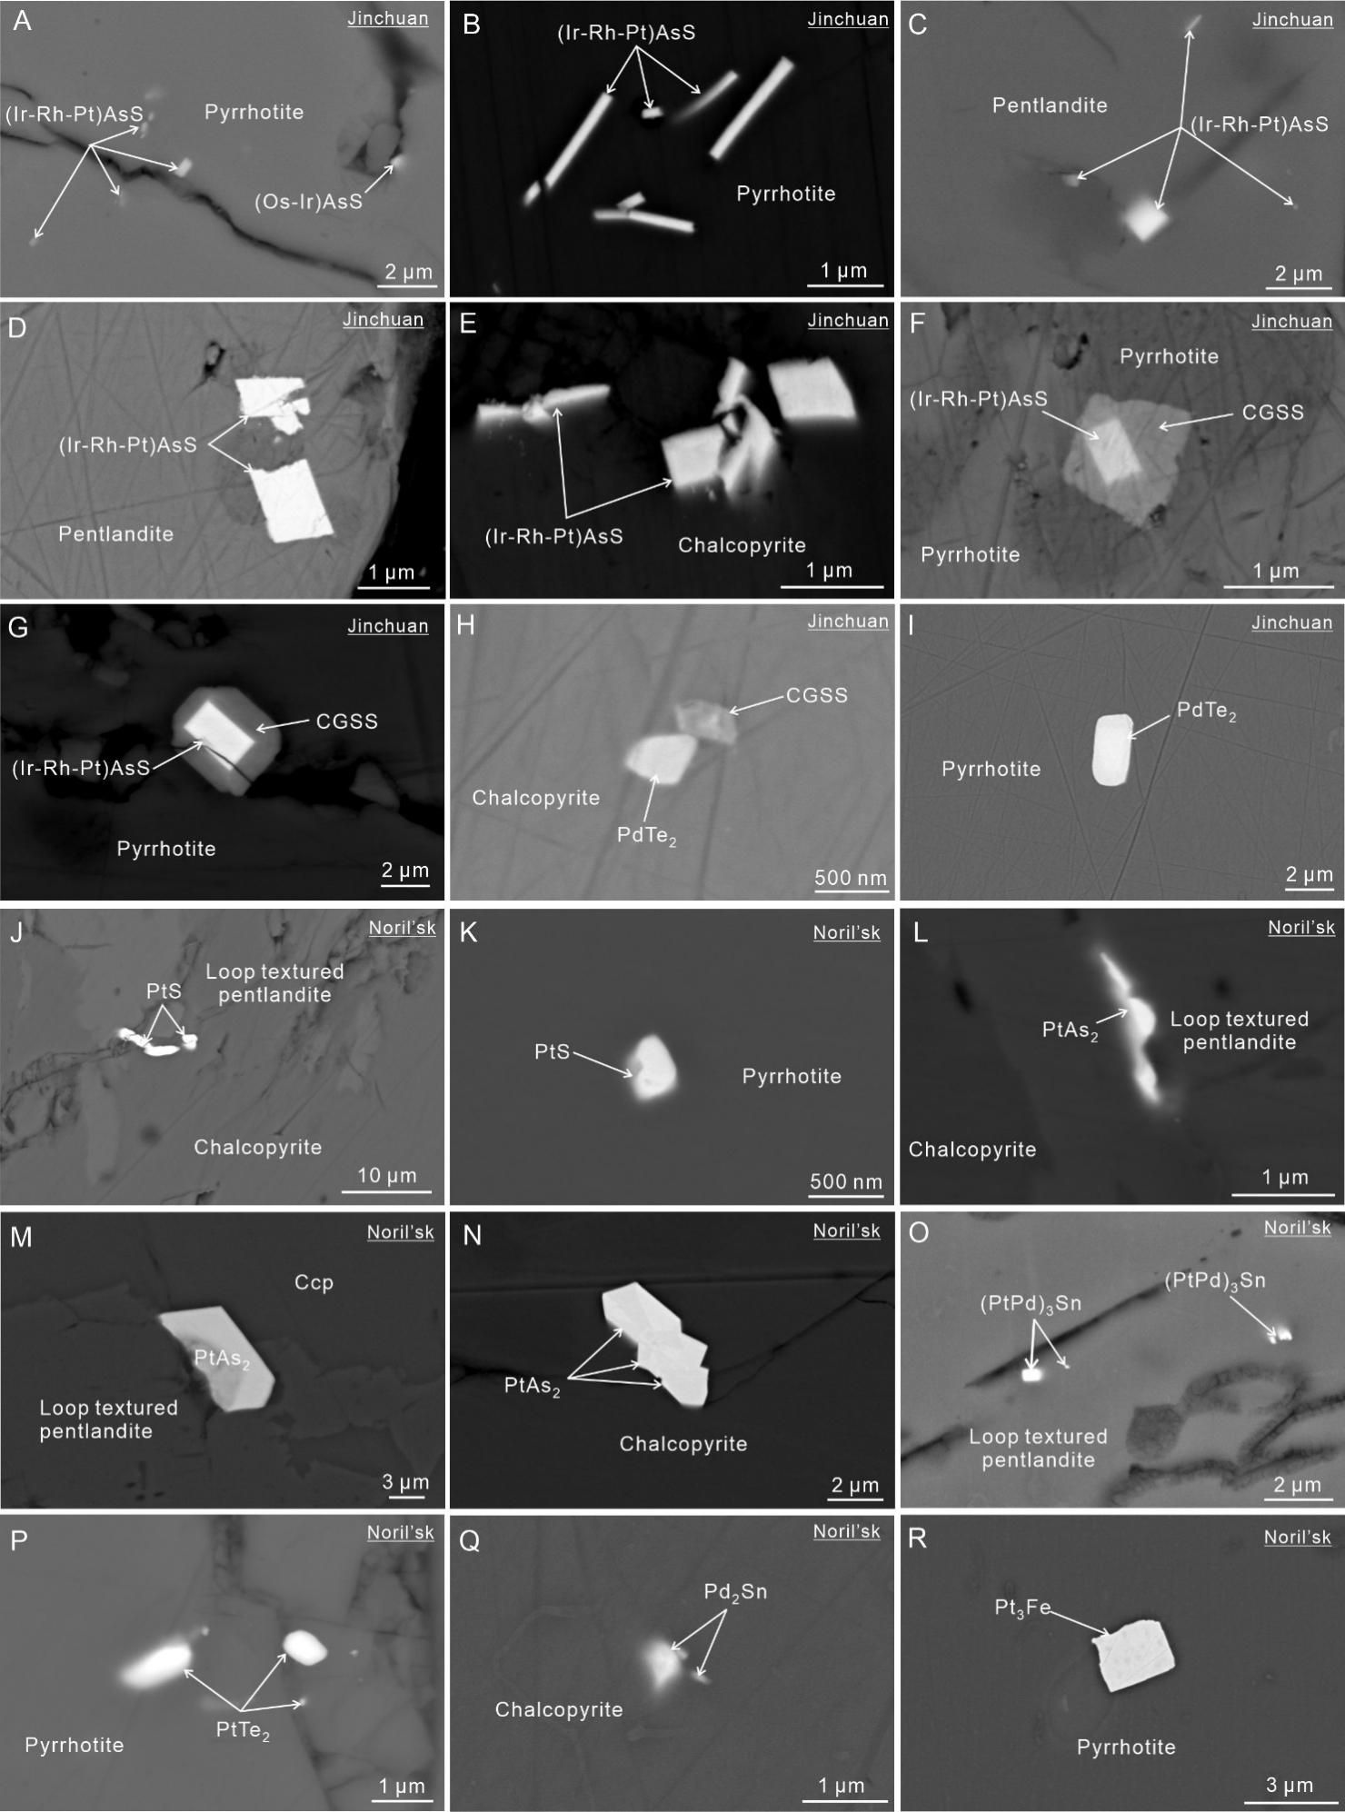
Fig. S4. Back-scattered electron images of typical platinum group minerals (PGM) in the BMS of the Jinchuan massive ores (A-I) and the Noril’sk massive ores (J-R). Abbreviations: (Ir-Rh-Pt)AsS = irarsite-hollingworthite-platarsite solid solution, CGSS = cobaltite-gersdorffite solid solution, PdTe₂ = merenskyite, PtS = cooperite, PtAs₂ = sperrylite, (PtPd)₃Sn = atokite, PtTe₂ = moncheite, Pd₂Sn = paolovite, Pt₃Fe = isoferroplatinum.

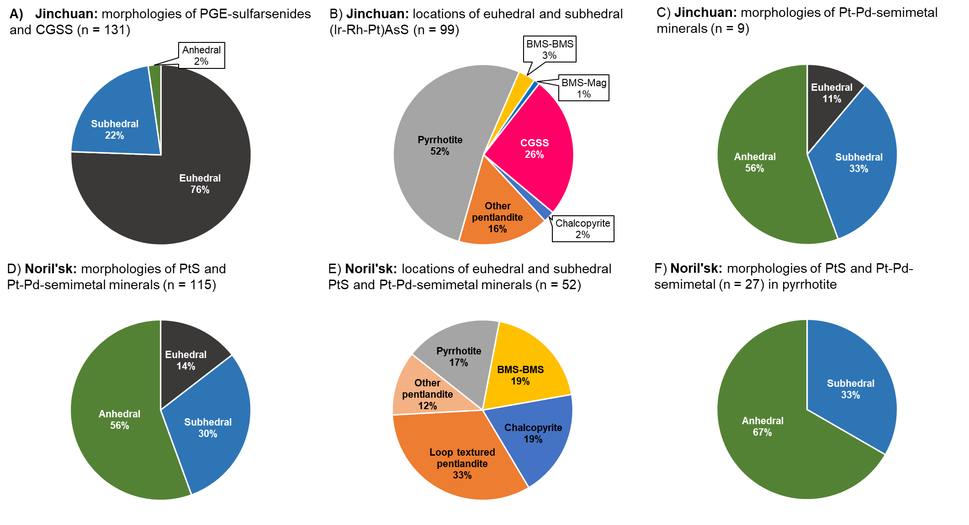
Fig. S5. Pie diagrams showing relative proportions (%) of PGM with different morphologies and locations from the Jinchuan massive ores (A-C) and the Noril’sk massive ores (D-F) based on numbers of PGM. Proportions of euhedral, subhedral and anhedral PGE-sulfarsenides and CGSS minerals (A) and Pt-Pd-semimetal minerals from the Jinchuan massive ores (C). Locations of euhedral to subhedral (Ir-Rh-Pt)AsS minerals from the Jinchuan massive ores (B). Proportions of euhedral, subhedral and anhedral of PtS and Pt-Pd-semimetal minerals (D) and PtS and Pd-Pd-semimetal minerals in pyrrhotite (F) from the Noril’sk massive ores. Locations of euhedral to subhedral PtS and Pt-Pd-semimetal minerals from the Noril’sk massive ores (E). Abbreviations: n = number of PGM, BMS = base metal sulfide, BMS-BMS = BMS grain boundaries. BMS-Mag = BMS-secondary magnetite boundary, Loop textured pentlandite = pentlandite formed through a peritectic reaction (Text S1), Other pentlandite = pentlandite occur as large subhedral grains, chain-like polycrystalline aggregates around pyrrhotite and exsolution flames in pyrrhotite.

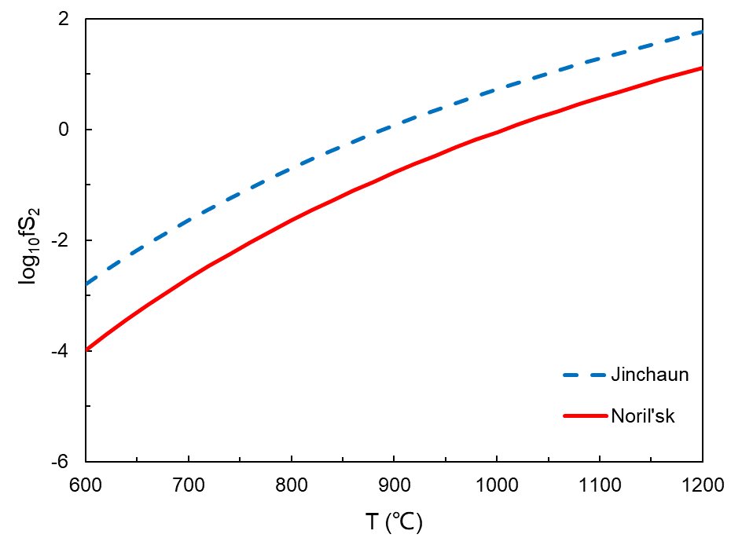
Fig. S6. Equilibrium temperature-dependent variations of sulfur fugacity of sulfide liquids from the Jinchuan deposit and the Noril’sk deposits. The sulfur fugacity was calculated based on the average compositions of pyrrhotite in the Jinchuan and Noril’sk massive ores (Table S4) using the equation from Toulmin and Barton (1964). The sulfide liquids of the Jinchuan deposit and the Noril’sk deposits were assumed to be closed systems based on the absence of magmatic magnetite at the sulfide-silicate boundaries (Fonseca et al., 2008). The pyrrhotite in both the deposits were assumed to be in equilibrium with the sulfide liquids during crystallization.

Tables S1-5
Caption for Table S1. Whole-rock concentrations of S, metals and semimetals of the Jinchuan and Noril’sk sulfide ores (as the Excel file which is uploaded separately).
Caption for Table S2. LA-ICPMS results for the metals and semimetals in pyrrhotite (Po), pentlandite (Pn) and chalcopyrite (Ccp) of the massive ores (MS) from the Jinchuan deposit and Noril'sk deposits (as the Excel file which is uploaded separately).

Table S3. The calculated proportion (%) of each element occurs as solid solution in pyrrhotite (Po), pentlandite (Pn), chalcopyrite (Ccp) of each sample and sum of averages from the Jinchuan deposit and the Noril'sk deposits.
Deposit | Sample | Ore type | Mineral | BMS proportion | Co | Ir | Ru | Rh | Pt | Pd | As | Sb | Te | Bi
Jinchuan | JC06-803 | MS | Po | 62 | 4 | 44 | 102 | 11 | 6 | 1 | 3 | 5 | 26 | 31
 |  |  | Pn | 17 | 116 | 17 | 30 | 13 | 2 | 88 | 1 | 2 | 50 | 3
 |  |  | Ccp | 5 | 0 | 1 | 2 | 0 | 0 | 0 | 0 | 1 | 2 | 6
 | JC06-806 | MS | Po | 64 | 3 | 3 | 110 | 5 | 8 | 2 | 3 | 11 | 18 | 15
 |  |  | Pn | 16 | 96 | 1 | 28 | 5 | 2 | 81 | 2 | 2 | 9 | 0
 |  |  | Ccp | 4 | 0 | 0 | 1 | 0 | 1 | 0 | 0 | 1 | 2 | 2
 | JC06-807 | MS | Po | 58 | 1 | 38 | 112 | 23 |  | 2 | 3 | 9 | 29 | 17
 |  |  | Pn | 17 | 109 | 7 | 35 | 53 | - | 80 | 1 | 4 | 75 | 2
 |  |  | Ccp | 7 | 0 | 0 | 1 | 0 |  | 0 | 0 | 1 | 4 | 3
 | JC06-809 | MS | Po | 56 | 1 | 41 | 116 | 19 | - | 1 | 4 | 8 | 23 | 19
 |  |  | Pn | 16 | 94 | 6 | 24 | 20 | - | 66 | 1 | 3 | 33 | 0
 |  |  | Ccp | 6 | 0 | 0 | 1 | 0 | - | 0 | 0 | 1 | 2 | 5
 | Average |  | Po | 60 | 2 | 31 | 110 | 14 | 7 | 2 | 3 | 8 | 24 | 21
 |  |  | Pn | 16 | 104 | 8 | 29 | 23 | 2 | 79 | 1 | 3 | 42 | 2
 |  |  | Ccp | 5 | 0 | 0 | 1 | 0 | 1 | 0 | 0 | 1 | 3 | 4
 | Sum of averages |  |  | 82 | 106 | 39 | 141 | 37 | 10 | 81 | 5 | 12 | 69 | 26
Noril'sk | Rn32 | MS | Po | 45 | 2 | 30 | 62 | 75 | 4 | 0 | 2 | - | 10 | 10
 |  |  | Pn | 8 | 98 | 6 | 12 | 4 | 11 | 81 | 1 | - | 1 | 3
 |  |  | Ccp | 11 | 0 | 1 | 7 | 1 | 1 | 0 | 1 | - | 4 | 2
 | Rn33 | MS | Po | 51 | 2 | 107 | 243 | 116 | 5 | 0 | 6 | 11 | 64 | 43
 |  |  | Pn | 8 | 102 | 10 | 30 | 6 | 23 | 56 | 3 | 4 | 12 | 9
 |  |  | Ccp | 7 | 0 | 6 | 6 | 2 | 2 | 0 | 2 | 2 | 18 | 3
 | Rn61 | MS | Po | 45 | 1 | 41 | 61 | 55 | 1 | 0 | - | - | 21 | 8
 |  |  | Pn | 10 | 107 | 8 | 8 | 10 | 3 | 104 | - | - | 4 | 3
 |  |  | Ccp | 7 | 0 | 0 | 1 | 0 | 1 | 0 | - | - | 14 | 1
 | Rn63 | MS | Po | 52 | 2 | 42 | 37 | 81 | 0 | 0 | 1 | 12 | 22 | 16
 |  |  | Pn | 11 | 105 | 4 | 5 | 8 | 20 | 169 | 1 | 1 | 5 | 6
 |  |  | Ccp | 10 | 0 | 0 | 1 | 1 | 0 | 0 | 0 | 3 | 9 | 2
 | Rn65 | MS | Po | 50 | 3 | 54 | 93 | 81 | 1 | 0 | 2 | 11 | 66 | 18
 |  |  | Pn | 8 | 95 | 4 | 6 | 5 | 1 | 96 | 1 | 3 | 16 | 21
 |  |  | Ccp | 5 | 0 | 0 | 0 | 0 | 0 | 0 | 0 | 2 | 10 | 4
 | Average |  | Po | 48 | 2 | 55 | 99 | 82 | 2 | 0 | 3 | 11 | 37 | 19
 |  |  | Pn | 9 | 101 | 6 | 12 | 7 | 12 | 101 | 1 | 3 | 8 | 8
 |  |  | Ccp | 8 | 0 | 1 | 3 | 1 | 1 | 0 | 1 | 3 | 11 | 3
 | Sum of averages |  |  | 66 | 103 | 63 | 114 | 89 | 15 | 101 | 5 | 17 | 55 | 30
Note: MS = massive ore, “-” = not calculated (whole-rock concentration is lower than the detection limit of LA-ICP-MS). The BMS proportion was calculated using BMS (wt%)/whole rock (wt%). Ru and Pd were averages from Ru99 and Ru101 and Pd105 and Pd106, respectively.
Table S4. EPMA average results for pyrrhotite (Po), pentlandite (Pn) and chalcopyrite (Ccp) of the massive ores (MS) from the Jinchuan deposit and the Noril'sk deposits.
Deposit | Sample No. | Ore type | Mineral | Point (n) | S | Co | Fe | Ni | Cu | Total
 |  |  |  |  | wt% | wt% | wt% | wt% | wt% | wt%
Jinchuan | JC06-803 | MS | Po | 4 | 39.1 | 0.1 | 58.8 | 0.5 | 0.0 | 98.4
 |  |  | Pn | 4 | 33.0 | 0.8 | 29.2 | 36.6 | 0.0 | 99.6
 |  |  | Ccp | 4 | 35.0 | 0.0 | 30.5 | 0.0 | 34.1 | 99.7
 | JC06-806 | MS | Po | 4 | 39.4 | 0.1 | 59.2 | 0.5 | 0.0 | 99.2
 |  |  | Pn | 5 | 33.4 | 0.8 | 30.4 | 35.3 | 0.0 | 100.0
 |  |  | Ccp | 4 | 35.2 | 0.0 | 30.9 | 0.0 | 34.0 | 100.1
 | JC06-807 | MS | Po | 8 | 38.8 | 0.1 | 59.2 | 0.5 | 0.0 | 98.5
 |  |  | Pn | 5 | 32.7 | 0.7 | 30.0 | 36.0 | 0.0 | 99.5
 |  |  | Ccp | 4 | 34.7 | 0.0 | 30.6 | 0.0 | 34.3 | 99.6
 | JC06-809 | MS | Po | 5 | 39.2 | 0.1 | 59.0 | 0.5 | 0.0 | 98.8
 |  |  | Pn | 4 | 32.9 | 0.8 | 30.0 | 36.0 | 0.0 | 99.6
 |  |  | Ccp | 4 | 35.2 | 0.0 | 30.5 | 0.0 | 34.1 | 99.8
Noril'sk | Rn32 | MS | Po | 4 | 38.4 | 0.1 | 59.5 | 0.6 | 0.0 | 98.5
 |  |  | Pn | 3 | 32.7 | 1.4 | 30.1 | 35.2 | 0.0 | 99.4
 |  |  | Ccp | 3 | 34.7 | 0.0 | 30.7 | 0.0 | 34.2 | 99.7
 | Rn33 | MS | Po | 3 | 38.6 | 0.1 | 59.4 | 0.5 | 0.0 | 98.6
 |  |  | Pn | 3 | 33.0 | 1.4 | 30.2 | 34.9 | 0.0 | 99.6
 |  |  | Ccp | 3 | 35.1 | 0.0 | 30.5 | 0.0 | 34.1 | 99.7
 | Rn61 | MS | Po | 3 | 38.1 | 0.1 | 60.3 | 0.5 | 0.0 | 99.0
 |  |  | Pn | 3 | 32.8 | 1.2 | 31.4 | 34.4 | 0.0 | 99.8
 |  |  | Ccp | 3 | 34.8 | 0.0 | 30.7 | 0.0 | 34.2 | 99.7
 | Rn63 | MS | Po | 3 | 38.4 | 0.1 | 59.8 | 0.5 | 0.0 | 98.7
 |  |  | Pn | 3 | 32.8 | 1.2 | 30.8 | 34.9 | 0.0 | 99.8
 |  |  | Ccp | 3 | 35.0 | 0.0 | 30.7 | 0.0 | 34.2 | 100.0
 | Rn65 | MS | Po | 4 | 38.4 | 0.1 | 59.6 | 0.5 | 0.0 | 98.6
 |  |  | Pn | 3 | 32.8 | 1.4 | 30.4 | 35.1 | 0.0 | 99.7
 |  |  | Ccp | 4 | 34.9 | 0.0 | 30.7 | 0.0 | 34.3 | 99.9

Table S5A. Number of PGE-sulfarsenides, CGSS and Pd-semimetal minerals found by SEM and their host minerals in the Jinchuan massive ores.
Locations | Mineral type
 | (Ir-Rh-Pt)AsS | Os(Ir-Ru)S₂ | CGSS | Pd-semimetal minerals
 |  |  |  | PdBiTe | PdTe₂
Po | 51 |  | 21 |  | 7
Pn | 16 | 1 | 2 | 1
Ccp | 2 |  | 6 |  | 1
CGSS | 25
Ccp-Ccp |  |  | 1
Po-Pn | 3 |  | 2
Po-Mag | 1
Total | 98 | 1 | 32 | 1 | 8
Note: (Ir-Rh-Pt)AsS = irarsite-hollingworthite-platarsite solid solution, Os(Ru-Ir)S₂ = erlichmanite, CGSS = cobaltite-gersdorffite solid solution, PdBiTe = michenerite, PdTe₂ = merenskyite, Po = pyrrhotite, Pn = pentlandite, Ccp = chalcopyrite, Ccp-Ccp and Po-Pn = BMS grain boundaries, Po-Mag = pyrrhotite-secondary magnetite boundaries.

Table S5B. Number of PtS, Pt-Pd-semimetal minerals, Pt₃Fe and Au-Ag minerals found by SEM and their host minerals in the Noril’sk massive ores.
Locations | Mineral type
 | PtS | Pt-semimetal minerals |  |  |  |  |  |  | Pd-semimetal minerals |  | Pt₃Fe | Au-Ag
 |  | PtAs₂ | PtSn | (PtPd)₃Sn | PtSb | PtTe₂ | PtBiTe | PtBi₂ | Pd₂Sn | PdTe₂
Po | 11 | 5 | 1 |  |  | 6 |  | 2 |  | 3 |  | 1
Pn | 7 | 15 | 2 | 9 |  | 5 | 4 |  |  |  |  | 3
Ccp | 4 | 12 |  |  | 1 | 1 | 2 |  | 1 |  | 1 | 4
Ccp-Ccp |  | 1
Ccp-Po | 1 | 4 |  |  |  |  | 4 |  |  |  | 1
Ccp-Pn | 2 | 2 |  |  |  |  | 1 |  | 2
Po-Pn | 4 | 2
BMS-Mag | 1 |  |  |  |  | 1 | 1
Total | 30 | 81 |  |  |  |  |  |  | 6 |  | 2 |  | 8
Note: PtS = cooperite, PtAs₂ = sperrylite, PtSn = niggliite, (PtPd)₃Sn = atokite, PtSb = stumpflite, PtTe₂ = moncheite, PtBiTe = maslovite, PtBi₂ = insizwaite, Pd₂Sn = paolovite, PdTe₂ = merenskyite, PdBiTe = michenerite, Pt₃Fe = isoferroplatinum, Au-Ag = electrum, Po = pyrrhotite, Pn = pentlandite, Ccp = chalcopyrite, Ccp-Ccp, Ccp-Po and Po-Pn = BMS-BMS grain boundaries, BMS-Mag = BMS-magmatic magnetite grain boundaries.
More than 75 % (based on numbers of PGM) of PtS and Pt-Pd-semimetal minerals found in pentlandite were enclosed in loop textured pentlandite (Text S1). PtS and Pt-Pd-semimetal minerals found in pyrrhotite (n = 27) are mostly anhedral (n = 18).

References
Chen L.M., Song X.Y., Danyushevsky L.V., Wang Y.S., Tian Y.L. and Xiao J.F. (2015) A laser ablation ICP-MS study of platinum-group and chalcophile elements in base metal sulfide minerals of the Jinchuan Ni–Cu sulfide deposit, NW China. Ore Geol. Rev. 65, 955-967.
Chen L.M., Song X.Y., Keays R.R., Tian Y.L., Wang Y.S., Deng Y.F. and Xiao J.F. (2013) Segregation and Fractionation of Magmatic Ni-Cu-PGE Sulfides in the Western Jinchuan Intrusion, Northwestern China: Insights from Platinum-group Element Geochemistry. Econ. Geol. 108, 1793-1811.
Duran C.J., Barnes S.J., Pleše P., Prašek M.K., Zientek M.L. and Pagé P. (2017) Fractional crystallization-induced variations in sulfides from the Noril’sk-Talnakh mining district (polar Siberia, Russia). Ore Geol. Rev. 90, 326-351.
Fonseca R.O., Campbell I.H., O’Neill H.S.C., Fitzgerald J.D. (2008) Oxygen solubility and speciation in sulphide-rich mattes. Geochim. Cosmochim. Acta 72, 2619-2635.
Li C., Barnes S.J., Makovicky E., RoseHansen J. and Makovicky M. (1996) Partitioning of nickel, copper, iridium, rhenium, platinum, and palladium between monosulfide solid solution and sulfide liquid: Effects of composition and temperature. Geochim. Cosmochim. Acta 60, 1231-1238.
Liu Y.N. and Brenan J. (2015) Partitioning of platinum-group elements (PGE) and chalcogens (Se, Te, As, Sb, Bi) between monosulfide-solid solution (MSS), intermediate solid solution (ISS) and sulfide liquid at controlled fO(2)-fS(2) conditions. Geochim. Cosmochim. Acta 159, 139-161.
Mansur E.T., Barnes S.J. and Duran C.J. (2019a) Textural and compositional evidence for the formation of pentlandite via peritectic reaction: Implications for the distribution of highly siderophile elements. Geology 47(4), 351-354.
Mungall J.E. and Brenan J.M. (2014) Partitioning of platinum-group elements and Au between sulfide liquid and basalt and the origins of mantle-crust fractionation of the chalcophile elements. Geochim. Cosmochim. Acta 125, 265-289.
Qi L., Gao J.F., Huang X.W., Hu J., Zhou M.F. and Zhong H. (2011) An improved digestion technique for determination of platinum group elements in geological samples. J. Anal. At. Spectrom. 26, 1900-1904.
Qi L. and Zhou M.-F. (2008) Platinum-group elemental and Sr-Nd-Os isotopic geochemistry of Permian Emeishan flood basalts in Guizhou Province, SW China. Chem. Geol. 248, 83-103.
Qi L., Zhou M.F. and Wang C.Y. (2004) Determination of low concentrations of platinum group elements in geological samples by ID-ICP-MS. J. Anal. At. Spectrom. 19, 1335-1339.
Toulmin P. and Barton P.B. (1964) A thermodynamic study of pyrite and pyrrhotite. Geochim. Cosmochim. Acta 28, 641-671.
Zientek M.L., Likhachev A.P., Kunilov V.E., Barnes S.J., Meier A.L., Carlson R.R., Briggs P.H., Fries T.L., Adrian B.M. and Lightfoot P.C. (1994) Cumulus processes and the composition of magmatic ore deposits: examples from the Talnakh District, Russia. In Proceedings of the Sudbury-Noril’sk Symposium Special volume (eds. Lightfoot P.C. and Naldrett. A.J.). Ministry of Northern Development and Mines, Ontario. pp. 373-392.

